

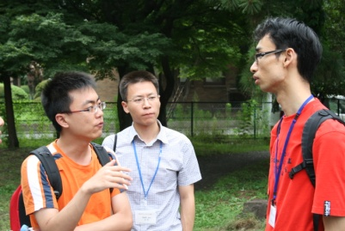
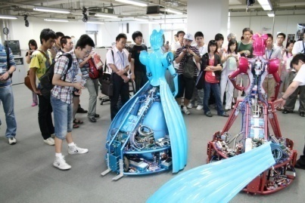
launches its 3rd summer program (TUSP 2009) this summer and invites students from our partner universities in Australia, China, Europe, and the United States.
This year’s TUSP will focus on frontier science and its impact on our society. Growing inequality, accelerating global warming, unprecedented health problems… All human beings on the earth cannot avoid these issues any longer. It is important for us to acknowledge all these detrimental problems are caused by human activities and we need to come together to take some measures right now.
In TUSP lecture series, we will examine causes and effects of obstacles we are facing, introduce possible approaches from a number of different angles, and see how frontier science can resolve these problems and positively impact our society in the future.
In addition, the field trips will let you experience both contemporary and traditional Japanese culture. Participation in this program will provide you an insight on what the world society needs in the future and how you can truly contribute to the society through your research. TUSP is your first step to become a world leading researcher of the future society!
For more information, please visit the website below.
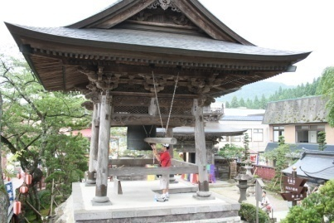
http://www. insc.tohoku.ac.jp/cms/index-e.cgi?num=80702204020

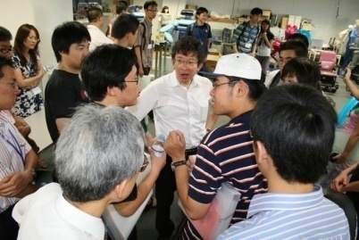

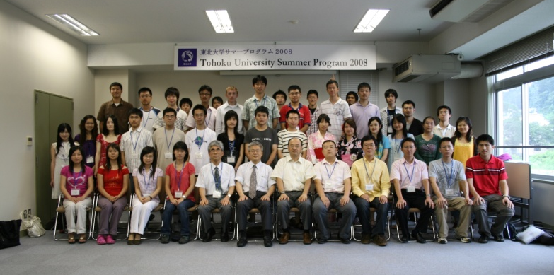

Contact

Phone:
E-mail:

